Document Number | UM-64NNP-V1_REWORK2
Author | Alex Campean
Client | University of Michigan / Chestek Lab
Project | UM-64NNP-V1
Statement of Work | - Remove FB1,FB2, FB3, FB4 and replace with 0402 zero-ohm resistors (Panasonic ERJ-2GE0R00X).  - Remove R101, R201, C103, C203.  - Add 1k, 0402 resistor (Panasonic ERJ-2RKF1001X) as R27.  - Add 49.9k, 0402 resistor (Panasonic ERJ-2RKF4992X) as R28.  - Add 2x 22uF, 0402 capacitors (Murata GRM158R61A226ME15J) to C103 and C203. Note that the capacitors must be stacked on top of each other.

Description
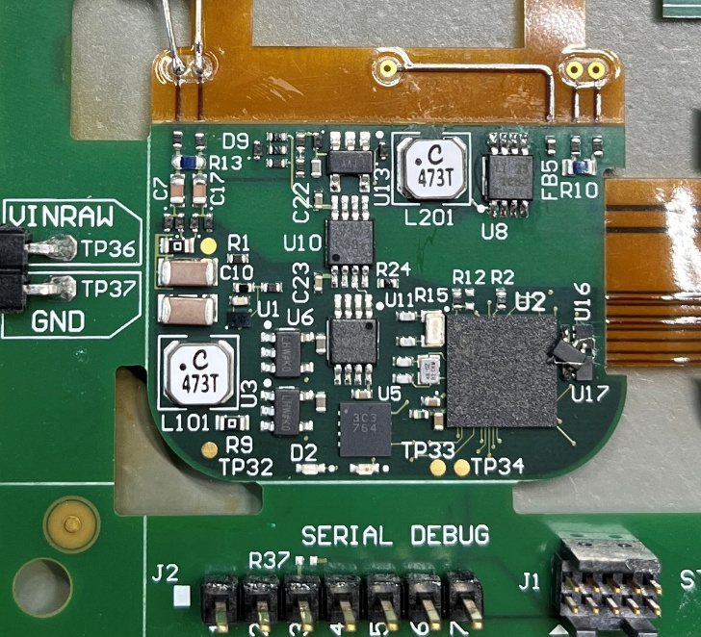  FB1,FB2  FB3,FB4 | Remove FB1, FB2, FB3, FB4 and replace with 0402 zero ohm resistor.

Description
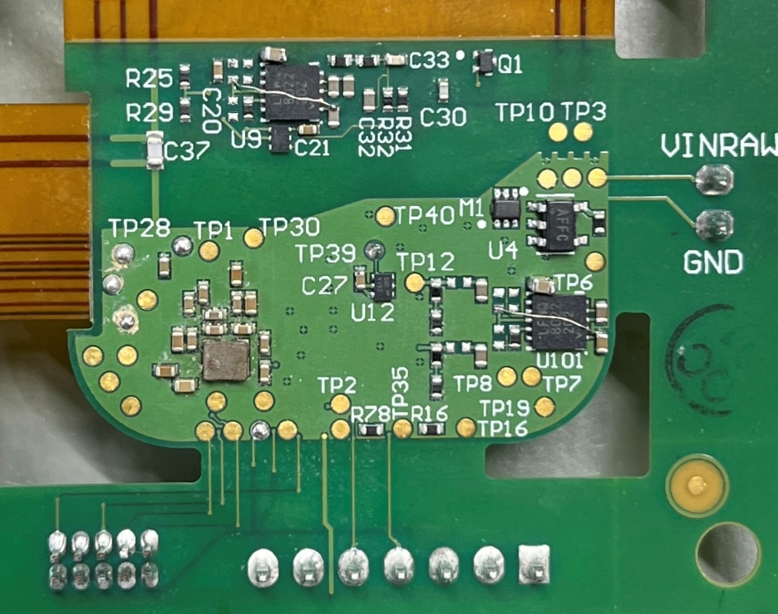  R201  R101  C103  C203 | Remove R101, R201, C103, C203.
C103  C203  R27  R28 | Add 1k, 0402 resistor as R27.  Add 49.9k, 0402 resistor as R28.  Add 2 stacked 22uF, 0402 capacitors to C103, C203.

Description
Jumper a wire across U101 and U201 as shown. Make sure the wire does not touch any other board metal. Only U101 shown.

